

Regulatory Approach

**OFFICIAL**

To receive this document in another format, [email Commission for Gender Equality in the Public Sector](mailto:enquiries@genderequalitycommission.vic.gov.au) <enquiries@genderequalitycommission.vic.gov.au>

Authorised and published by the Victorian Government, 1 Treasury Place, Melbourne.

© State of Victoria, Commission for Gender Equality in the Public Sector, April, 2025.

Except where otherwise indicated, the images in this document show models and illustrative settings only, and do not necessarily depict actual services, facilities or recipients of services. This document may contain images of deceased Aboriginal and Torres Strait Islander peoples.

In this document, ‘Aboriginal’ refers to both Aboriginal and Torres Strait Islander people. ‘Indigenous’ or ‘Koori/Koorie’ is retained when part of the title of a report, program or quotation.

ISBN 978-1-76130-796-6 (pdf/online/MS word)

Available at the [Commission for Gender Equality in the Public Sector website](http://www.genderequalitycommission.vic.gov.au) <www.genderequalitycommission.vic.gov.au>

Contents

Overview 4

Who we are 4

The Gender Equality Act 2020 4

Who we regulate 4

What we regulate 5

Our co-regulators 5

Our regulatory approach 5

Regulatory principles 6

Taking a risk-based approach to reducing harm 7

Our regulatory tools 10

Hierarchy of regulatory activities 10

Expectations of duty holders 11

Enforcement approach 11

Reviewing regulatory decisions 12

# Overview

The Public Sector Gender Equality Commissioner was established under the [*Gender Equality Act 2020*](https://www.legislation.vic.gov.au/in-force/acts/gender-equality-act-2020)*.* The Commissioner and their staff oversee the Act and promote gender equality in the public sector workforce and wider Victorian community. This document outlines how we will perform as a leading practice regulator.

# Who we are

The Commissioner is appointed by the Minister for Women. The Commissioner is supported by staff who make up the Commission for Gender Equality in the Public Sector.

Together we promote and advance the objectives of the Act.

We exist to ensure organisations meet their obligations under the Act. We do this by:

* providing education and support, including guidance materials and other resources to help duty holders comply
* raising awareness about intersectional gender inequality in workplaces and the community
* supporting compliance assessments and reporting on gender equality in the public sector
* investing in gender equality research.

## The Gender Equality Act 2020

The Act aims to:

* promote and support gender equality and improve the status of women
* remove systemic causes of gender inequality in policy, programs and delivery of services in workplaces and communities
* recognise that gender inequality can be compounded by disadvantage or discrimination based on other attributes, such as Aboriginality, age, disability, ethnicity, race, religion and sexual orientation
* address disadvantage, stigma, stereotyping, prejudice and violence through structural change
* help people of different genders participate in economic and social activities
* promote the right to equality.

The Act is a powerful tool and supports the state to lead by example in advancing strong gender equality reforms.

Progress towards gender equality makes our communities fairer. It leads to significant social and economic benefits and ensures public sector efforts meet the needs of people of all genders. By targeting the drivers of gender inequality, the Act ensures more Victorians can enjoy equal opportunities, responsibilities and outcomes free of stigma, stereotyping, prejudice and violence.

# Who we regulate

The Act applies to certain public sector organisations with 50 or more employees. Currently, there are around 300 duty holders, making up 12% of the Victorian workforce.

We communicate with the head of organisation, governing body (board chair), and any other nominated people, so that senior leaders are accountable for their obligations under the Act.

# What we regulate

The Commissioner regulates duty holders (Victorian public sector, local councils and universities) to:

* take action towards achieving workplace gender equality
* consider and promote gender equity in their policies, programs and services.

We support duty holders to understand their obligations and voluntarily comply with them.

Our primary functions are:

* monitoring and supporting duty holders to comply with the Act
* reviewing, assessing and publishing **gender equality action plans** (GEAPs)
* reviewing, assessing and publishing the results of **workplace gender audits** (WGAs)
* provide guidance on **gender impact assessments** (GIAs)
* reviewing and assessing **progress reports**
* resolving workplace disputes relating to systemic gender equality issues.

The Commissioner’s regulatory function is unique because it reaches beyond workplaces, regulating the work that duty holders deliver for the community. Through GIAs, duty holders are required to apply a gendered lens to policy, programs and services that have a direct and significant impact on the community.

## Our co-regulators

We work with entities that have complementary regulatory roles. We share information (including data collected under the Act where appropriate and permissible) and collaborate on research and resources.

Working with co-regulators expands our influence. Co-regulators can use information that we collect under the Act to inform their practice. This activity delivers on the positive duty in the Act to promote gender equality.

Partners include the Victorian Equal Opportunity and Human Rights Commission, the Victorian Public Sector Commission, Local Government Victoria and the Workplace Gender Equality Agency.

Some Victorian co-regulators are also duty holders under the Act. To manage this, we have processes in place to mitigate any real or perceived conflicts of interest. This includes being clear about the purpose of each engagement with our co-regulators.

# Our regulatory approach

Our regulatory approach uses guidance, education, and deterrence to motivate action and improve intersectional gender equality.

We apply a risk-based approach to prioritising and directing effort to where it will make the biggest difference.

The Commissioner’s regulatory responsibilities are determined by the legislation they administer. The Commissioner and their staff strive to be a consistent, responsive and trusted regulator that acts proportionately.

We work with duty holders to improve gender equality in public sector workplaces and to eliminate systemic causes of gender inequality in policy programs and services delivered to the community.

The regulatory approach aims to be evidence-led, risk-based and transparent. We are committed to reducing barriers to compliance and regulatory duplication and burden. We will use the full range of regulatory tools available to encourage voluntary compliance and reduce the harm caused by gender inequality.

Tools include providing guidance and advice, data analysis, compliance monitoring and reporting.

## Regulatory principles

These principles inform our regulatory approach.

| Principle | Our commitments |
| --- | --- |
| **Effective** | * We assess risk and allocate resources where they have the greatest impact on eliminating intersectional gender inequality. * We support duty holders with resources that are effective in helping them eliminate systemic gender inequality. |
| **Proportional** | * We take regulatory action that is proportionate to the risk and consider the behaviour and response of the duty holder. * We take regulatory action that is proportionate to the size and capacity of a duty holder. |
| **Accountable** | * We are transparent, objective and open in our decision making and clearly set expectations. * We evaluate and continually improve our practices and publicly report on our regulatory approach. * We share information about our compliance processes and provide feedback on compliance. * We strive to be as timely and responsive as possible when distributing new guidance and providing feedback on compliance. |
| **Inclusive** | * We continue to build the evidence base and provide education on intersectional gender equality. * We aim to improve intersectional data collection and support duty holders in achieving this goal. |
| **Fair** | * We are consistent and predictable in our approach to administering the Act. * When deciding regulatory responses, we ensure the process is fair and consistent. |

## Taking a risk-based approach to reducing harm

In line with *Towards best practice guide for regulators,[1]* we focus on managing the risk of gender-based harm occurring.

A risk-based approach involves applying effort and resources to target actions and behaviours that present the highest risk of causing gender-based harm.

This approach allows us to:

* make informed decisions about targeting industries and activities of highest risk
* monitor regulatory activity to ensure it is contemporary and fit-for-purpose
* use a range of regulatory tools, proportionate to the risk of gender-based harm identified
* be proactive to solve problems rather than being reactive to non-compliance
* scan the environment to observe and respond to new and emerging issues
* respond effectively when non-compliance is identified.

This approach ensures our small team can effectively target activity to where it will have the biggest impact.

What is gender-based harm?

Harm has a broad definition. It can include problems that affect individuals, groups, workplaces, the community or environment.

Harms can affect anyone, but some people (and in this case, some genders) may be more vulnerable.

We regulate to prevent, minimise and eliminate harm in the workplace and community that comes from:

* gender-based discrimination, prejudice and disadvantage
* gender-role stereotyping where this leads to economic or social inequality
* gendered distribution of labour that leads to economic and social inequality
* gendered distribution of power where this creates physical, economic or psychological harm
* sexual harassment and other forms of gender-based violence.

### Assessing risk of gender-based harm

When assessing the risk of gender-based harm we consider:

The **likelihood** of duty holders failing to address gender inequality in their workplace or policies, programs and services.

The **consequence of non-compliance**. That is the extent and significance of duty holders:

* not having effective strategies in place to address gender inequality
* failing to take necessary and proportionate action towards gender equality
* failing to consider and promote gender equality.

This includes considering the scale and concentration (within an industry) of the harm.

Figure 1: Assessing risk of gender-based harm

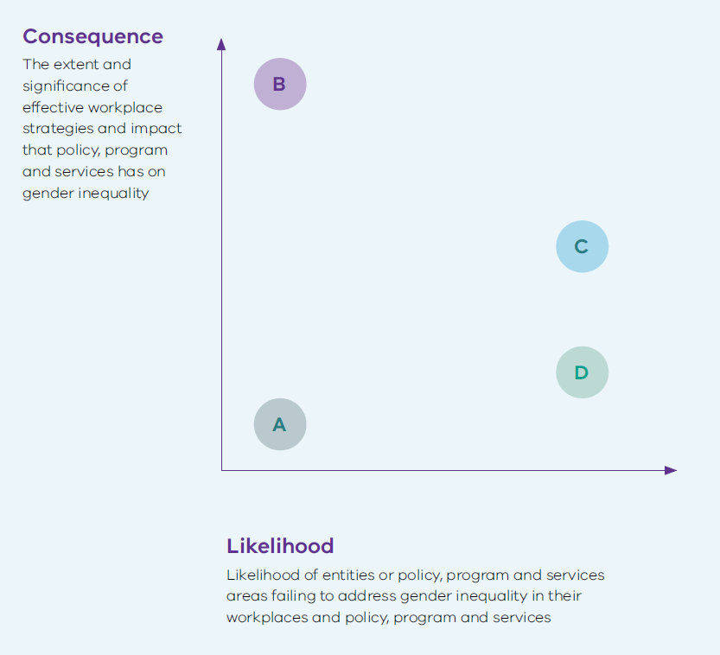

A – Lower priority for intervention. Subject to general observation and guidance.

B – Risk of greater consequence that may need dedicated effort to understand and respond accordingly. These are more likely to be strategic priorities.

C – Intervening where the likelihood and consequences are both moderate to high is a high priority.

D – Lower priority given relative low consequences. In these cases, guidance or education is likely to be effective.

Table 1: Likelihood of non-compliance

| Rating | Description of duty holder | Description of policy, program or service |
| --- | --- | --- |
| **Unlikely** | * General willingness to comply and supportive leaders, executives and board * History of engagement with Commission * Demonstrates an understanding of intersectional gender equality * GIAs are embedded into business-as-usual and is building staff capability * GEAP and GIA recommendations endorsed by leaders * Adequate resourcing of the obligations proportional to organisation size and needs | * Diverse workforce * Proportionate number of GIAs completed or in progress * GIA recommendations show sophisticated understanding of the issues and are implementable * Adequate resources dedicated to GIAs |
| **Possible** | * Limited engagement with Commission * Poor attitude to compliance * Issues identified in GEAPs showing lack of understanding and/or commitment to gender equality * Issues identified with the quality of audit data * Changes in staff leading GEAP implementation and progress reports, without adequate handover | * Workforce relatively static * Superficial reporting on GIAs * Some resources dedicated to GIAs |
| **Likely** | * Low or no previous engagement with Commission * Past non-compliance despite engagement * Known compliance issues in related areas (e.g. employment law) and/or unfavourable media or attention to issues (e.g. bullying or toxic workplace culture) * Suspected systemic gender equality issues internally * Progress report indicates confusion about the goals of gender equality * Progress report demonstrates lack of capacity to link actions and strategies to gender equality issues in the workplace * Previous failure to report on GEAPs or no GIAs reported in progress reports and failure to provide justified reasoning | * Capability gap in understanding how gender equality considerations relate to their service area * Insufficient resources dedicated to GIAs |
| **Almost certain** | * Resistant to or avoid engaging with Commission * Past non-compliance * Non-compliance in related areas and/or media exposing problematic practices or culture * Known systemic gender equality issues internally (e.g. dispute resolution application) | * Overt resistance towards gender equality initiatives * No resources dedicated to completing GIAs |

Table 2 provides guidance on the consequences of non-compliance.

Even when the likelihood of non-compliance is low, if the consequences are severe, more regulatory effort will be directed to ensure risks are managed.

Table 2: Scale of consequences of non-compliance

| Type of harm | Minor | Medium | Major | Severe |
| --- | --- | --- | --- | --- |
| **Cultural and social** | Lack of equitable representation of people of different genders contributing to invisibility | Failure to recognise how people of different genders experience and access the workplace, community services and programs that  contributes to engagement gaps | Barriers to participation by people of different genders persist in the workplace, community service or program design, and decision-making | Active exclusion of people of different genders in the workplace, or in the way community policies, programs or services are designed and delivered |
| **Economic** | Minor impact on achieving fair economic outcomes for people of different genders | Some barriers to economic participation and fair economic outcomes for people of different genders | Reinforces unequal economic status between people of different genders | Directly drives unequal economic outcomes for people of different genders |
| **Health & safety** | Experience of unease or discomfort for people of different genders but does not reduce participation in or access to services or the workplace | Experience of disrespect, discomfort, risk to physical or psychological safety, or exclusion means that people of different genders don’t participate equally, or as fully and may need to take protective actions | Failure to consider physical and psychological health and safety risks and needs based on gender excludes people of different genders. | Policies, practices and culture enable harassment, discrimination, marginalisation, physical or psychological harm, violence or trauma that significantly impacts people of different genders |

# Our regulatory tools

We are working towards cultural change. We place a strong emphasis on supporting duty holders to comply.

Action to address non-compliance is graduated. In most cases, we will encourage compliance through guidance and advice. More significant enforcement sanctions are used for duty holders that are uncooperative or have repeated or serious compliance concerns.

## Hierarchy of regulatory activities

| **Approach** | **What it looks like** | **Examples** |
| --- | --- | --- |
| **Communicate** | We communicate and share information with duty holders on why gender equality is important and what works to improve it | * Commissioner and staff meetings with duty holders * Supporting communities of practice to encourage peer education * Conducting research or partnering with researchers on gender equality issues |
| **Support to comply** | We provide practical guidance and templates for duty holders to maximise voluntary compliance | * Publishing guidance on mandatory standards and compliance requirements * Providing education and training * Promoting best practice in Commission communications channels * Targeting communications to draw focus to compliance issues in the sector |
| **Monitor** | We use information and data collected to identify sectors (or sub-sectors) that need proactive monitoring or extra support | * Partnering with co-regulators to influence particular industries * Publicly reporting on compliance issues * Issuing broad public warnings about a compliance issue * Convening forums to raise awareness of a particular compliance issue |
| **Remedy** | We use informal methods to remedy non-compliance by working with duty holders. If unsuccessful, formal notices and written undertakings may be used | * Targeting correspondence to Boards, executives and heads of organisations * Issuing a compliance notice * Accepting a written undertaking from a duty holder in response to a notice * Responding to specific disputes between employees and employers to resolve systemic gender equality issues |
| **Sanction** | We may take more formal and public action to deter non-compliance and promote greater transparency and accountability | * Reporting publicly on enforcement actions taken by the Commissioner * Raising issues with the Minister responsible for the duty holder * Recommending action that the Minister take against the duty holder * Naming the organisation and the obligation they failed to comply with * Referring the matter to VCAT |

# Expectations of duty holders

We expect all duty holders to make a genuine effort to comply with their obligations under the law.

A duty holder complies if they adhere to all requirements and obligations under the Act and associated regulations. They must also take into account any guidance administered by the Commissioner or Minister.

This means:

* prioritising appropriate resourcing
* promoting gender equality
* demonstrating material progress in relation to the workplace gender equality indicators.

Compliance is an ongoing process where duty holders regularly assess their risk of not complying and seek to improve their practices.

# Enforcement approach

If a duty holder fails to comply, the Commissioner will work directly with them to try and achieve voluntary compliance.

If non-compliance continues, the Commissioner will use the compliance and enforcement powers provided under the Act:

* issuing a compliance notice to require remedial action
* accepting a written undertaking from the duty holder that they will take certain action
* recommending that the Minister take action against the organisation
* naming the organisation and their failure to comply on the Commission’s website
* making an application to the Victorian Civil and Administrative Tribunal (VCAT) for an order directing the organisation to comply with a compliance notice.

Intervention will be proportionate to:

* the harm arising from non-compliance
* the attitude to compliance and culpability
* capacity and ability of the duty holder
* what is considered reasonable and material progress.

Figure 2: Escalated and responsive approach to enforcement

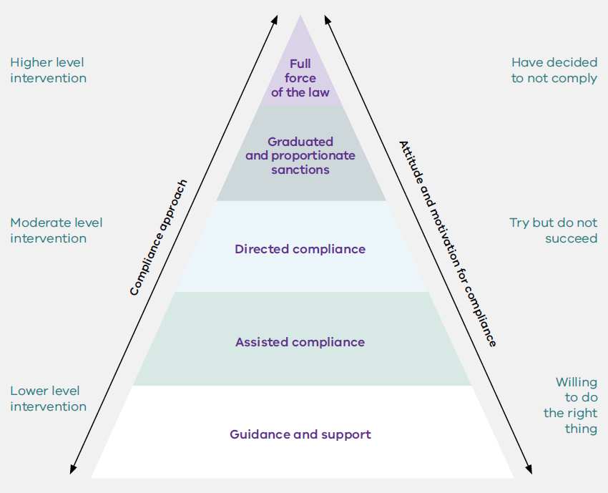

## Reviewing regulatory decisions

We hold ourselves accountable by:

* being open and transparent in our conduct and explaining our decisions
* being open to scrutiny and review
* showing integrity in our efforts to eliminate gender inequality
* committing to continuous improvement.

Duty holders can request an internal review of compliance feedback or decisions. If a duty holder disagrees with a compliance notice issued by the Commissioner, they have 14 days after receiving the compliance notice to give a written response to the Commissioner outlining the reasons for disagreeing with the notice and can ask for the decision to be reconsidered.

After considering the written response from the duty holder, the Commissioner may withdraw, amend or confirm the compliance notice. An internal review of the compliance feedback or decision may be completed to inform this. If the compliance notice is confirmed or amended, the notice will specify a period within which the duty holder must comply.

### Alternative avenues for review

If the Commissioner confirms a compliance notice, and the duty holder continues to disagree with the decision, they can apply to VCAT for a review of the decision to confirm the notice.

An application for review must be made in writing to VCAT within 28 days of the duty holder receiving the notice of the Commissioner's decision.

1. <https://www.vic.gov.au/towards-best-practice-guide-regulators>