Making your progress report accessible for web publishing

Most organisations covered by the Gender Equality Act will need to meet the [Web Content Accessibility Guidelines Version 2.1](https://www.w3.org/TR/WCAG21/) Level AA standard.

This guide will help you prepare your Excel spreadsheet to address known accessibility issues in the template. It will take 5-10 minutes.

## Unprotect the workbook

The workbook is ‘protected’ by default. This is just to prevent accidental deletion of critical fields.

To make your progress report accessible for web publishing you may need to ‘unprotect’ it. Follow the below steps.

1. In Excel, open the **File** menu.

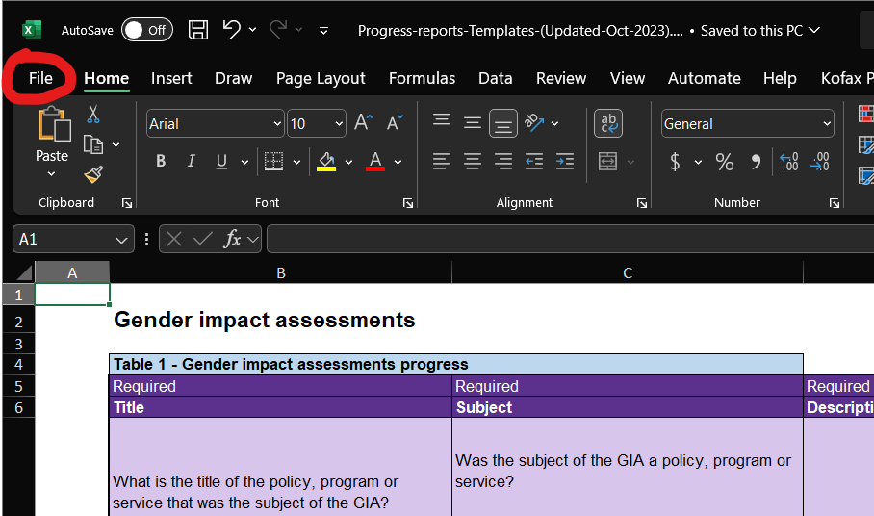

1. Select **Info**, then click on ‘Unprotect’ against each sheet in the workbook.

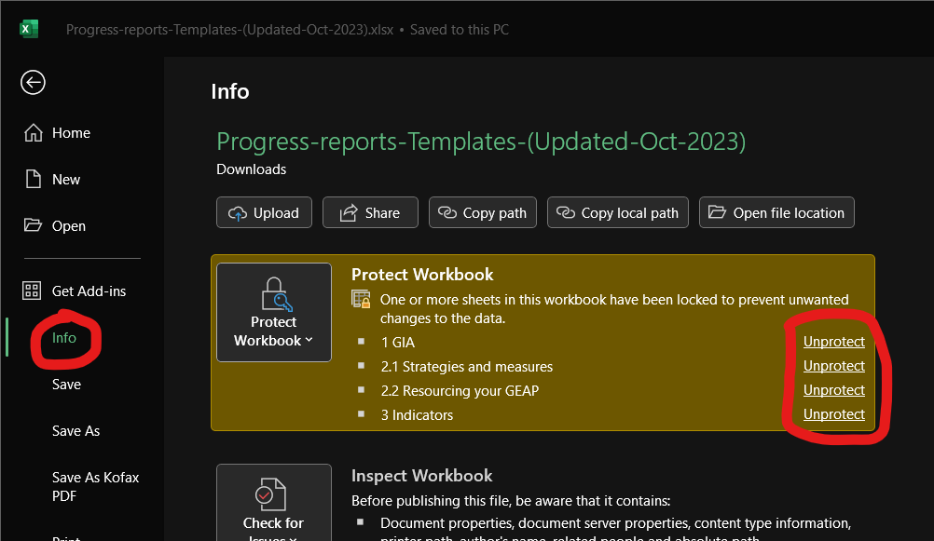

You should now be able to amend your progress report for accessibility through following the below steps.

## Run the accessibility checker

1. In Excel, open the **File** menu.



1. Select **Info**, then **Check for Issues**.

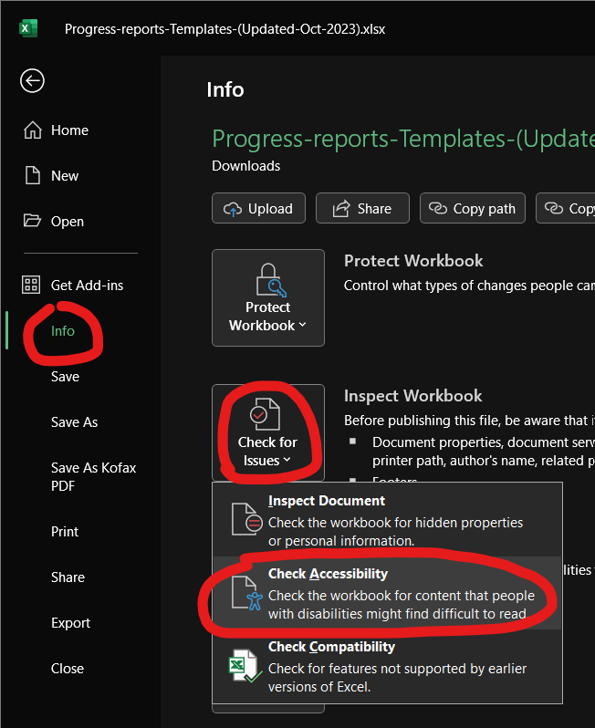

The Accessibility Assistant will open on the right of your screen. It will show you issues that need to be addressed, and how to fix them. This may look different, depending on which version of Excel you are using. It might list these as ‘errors’ and ‘warnings’.

We are aware of 2 issues in the template that you can easily fix.

## Hard-to-read text contrast

This issue occurs in tab **1 GIA** and tab **2.1 Strategies and measures**.

Screenshot showing 2 rows in an Excel document, with text on a black background

There are 2 rows with a black fill colour, as above.

Option 1. Delete before publishing, as this is an instruction for filling in the template. You can either delete the rows individually, or the text.

Option 2: Follow the recommendation of the accessibility assistant to change the text colour.

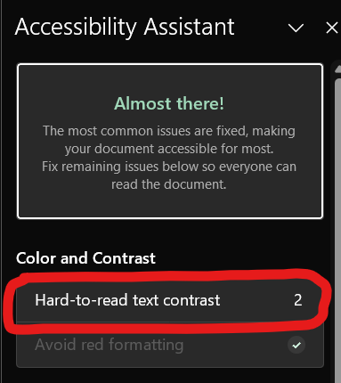

* Click on the issue (where it shows the number 2).
* Select a colour.
* It will then take you to the next instance to fix.

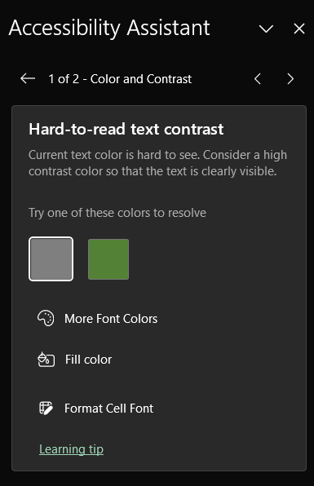

## Use of merged cells

This issue occurs in **2.1 Strategies and measures** and **3 Indicators**.

This is in a recommended field.

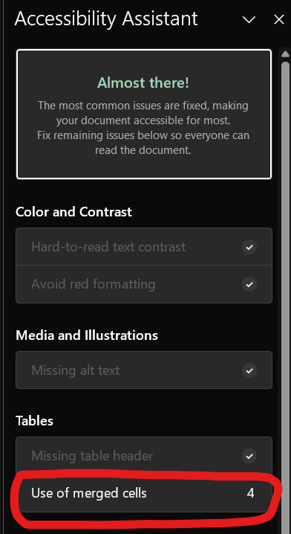

Option 1. If your organisation did not provide data in this field, you can delete the columns. You can also delete the example at the bottom where this issue occurs, as this does not need to be published.

Option 2. In the Accessibility Assistant, click on ‘Split cells’ for each instance.

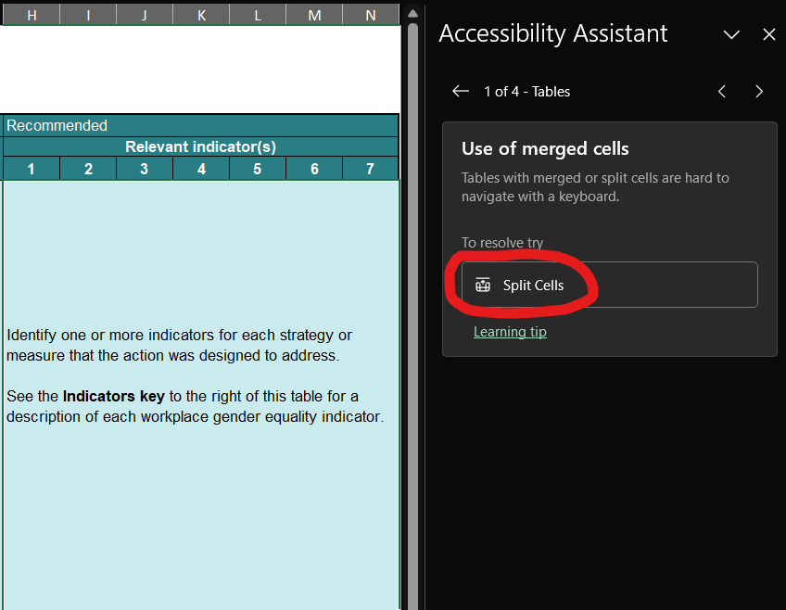

This will separate the cells that have been merged.

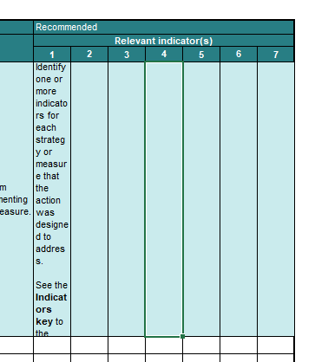

You may want to copy and paste the text into each cell. You can do this by selecting the first cell, then dragging the bottom corner across the other cells.

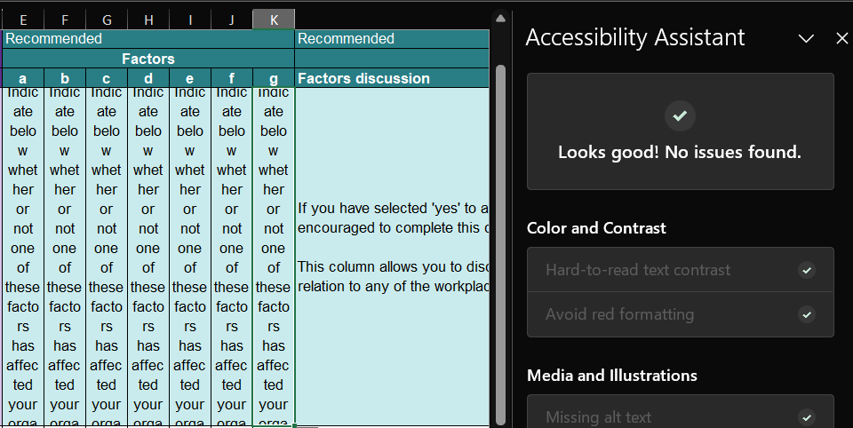

The Accessibility Assistant has found no further issues.

# Other options

If these steps don’t work for you, or you encounter other accessibility issues you can:

* Publish a [HTML summary](https://www.vic.gov.au/make-content-accessible#avoid-using-documents) of your progress report, as well as the Excel file.
* Add an [accessibility notice](https://www.vic.gov.au/digital-accessibility-requirements#accessibility-notice-to-display-on-page).

Department of Families, Fairness and Housing provides an example of both of these options: <https://www.dffh.vic.gov.au/publications/gender-equality-progress-report-2021-23>

For more guidance see: <https://www.vic.gov.au/make-content-accessible>

If you have any issues or queries, please contact the Commission at [enquiries@genderequalitycommission.vic.gov.au](mailto:enquiries@genderequalitycommission.vic.gov.au)